Chapter: Mastering Docker Multi-Stage Builds for Optimized Containerization

Introduction: The Importance of Docker Multi-Stage Builds
- [00:00 → 01:41]
This chapter delves into Docker multi-stage builds, a crucial technique for optimizing Docker container images by reducing their size and improving performance. Building on foundational Docker knowledge—including container fundamentals, image creation, and basic Docker commands—this topic is essential for developers aiming to produce efficient, secure, and production-ready containers. Key vocabulary includes Docker image, multi-stage build, base image, stage, build artifacts, and Alpine image. The multi-stage build process addresses common challenges such as unnecessarily large images (e.g., over 200 MB even with Alpine base) by splitting build steps into distinct stages and selectively copying only needed files. This practice enhances performance, security, and deployment readiness.
- Advanced bullet points:
  - Multi-stage builds help reduce Docker image size by isolating build and deployment stages.
  - They improve container performance and security by copying only essential files.
  - The concept builds upon prior Docker fundamentals, including understanding of images, containers, and commands like docker build, docker run, and docker push.
  - Best practice in modern Docker workflows, especially for production systems.

Section 1: Setting Up the Multi-Stage Dockerfile
- [02:17 → 07:03]
The process starts by cloning a sample application and creating a new Dockerfile without any preexisting content. The first stage, named installer, uses the node:18-alpine base image, selected for its lightweight nature. The Dockerfile instructions include:
- Setting a working directory (WORKDIR /slapp) inside the container.
- Copying dependency files (package.json and package-lock.json) into the container.
- Running npm install to fetch dependencies.
- Copying application source files (but only to the build layer, not the final container image).
- Running the npm run build command to generate production-ready build artifacts in a build folder.
This stage focuses solely on preparing the application environment and generating static files but does not yet prepare the container for deployment.
- Advanced bullet points:
  - Use of named stages for clarity (AS installer).
  - Selective copying of files using wildcards, improving efficiency.
  - Separation of dependency installation and build steps.
  - Importance of understanding the difference between Docker layers and final container contents.

Section 2: Creating the Deployment Stage with Nginx
- [05:38 → 08:55]
The second stage, termed deployer, uses an nginx:latest image to serve the built static files. The key action is copying only the build artifacts (the contents of the build folder) from the installer stage into the Nginx default static content directory (/usr/share/nginx/html). This selective copying excludes unnecessary files such as node_modules and source code, drastically minimizing the final image size and reducing attack surface by excluding development dependencies.
This two-stage approach exemplifies the essence of multi-stage builds: separating build-time dependencies from runtime dependencies.
- Advanced bullet points:
  - Use of COPY --from=installer to pull files from a previous build stage.
  - Deploying only static assets needed to serve the application.
  - Benefits: reduced image size, improved build speed, enhanced security.
  - Final image contains no build tools or source code beyond static files.
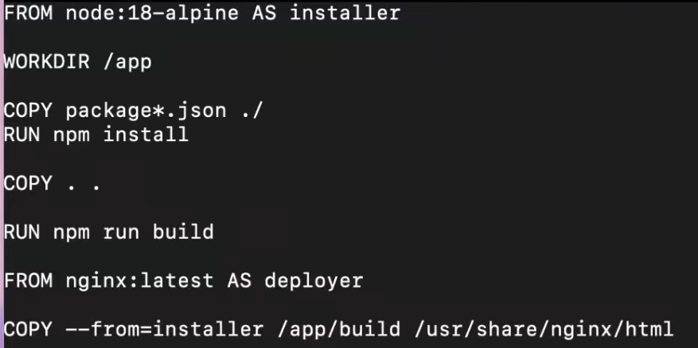

Section 3: Building and Running the Multi-Stage Image
- [08:55 → 10:46]
The image is built using the command docker build -t multistage ., demonstrating how to specify the Dockerfile location and image tag. Initial errors around syntax (e.g., the proper use of FROM ... AS and the correct spelling of Dockerfile commands) are addressed, emphasizing the importance of correct syntax in Dockerfiles.
The resulting image was about 195 MB, significantly smaller than previous builds that included all dependencies, despite the application being larger and including Nginx.
- Advanced bullet points:
  - Correct syntax for multi-stage builds: FROM node:18-alpine AS installer.
  - Image size reduction from over 200 MB to 195 MB.
  - Demonstrates practical debugging and iterative development of Dockerfiles.
  - Encourages attention to detail to avoid build errors.

Section 4: Managing Docker Images and Containers
- [10:46 → 16:55]
The video covers essential Docker management commands:
- Cleaning up unused images with docker image rm <image_name> to save local disk space.
- Checking running containers using docker ps.
- Running containers with exposed ports using docker run -p 3000:3000 multistage.
- Investigating container logs using docker logs <container_id> to troubleshoot runtime issues.
- Entering running containers with docker exec -it <container_id> sh to inspect the file system and running processes.
Inside the container, the working directory defaults to root (/) since the final stage did not specify a working directory. The static files are found under /usr/share/nginx/html, confirming that only the build folder was copied over. The container is minimal, containing only essential binaries and files, consistent with the Alpine and Nginx base images.
- Advanced bullet points:
  - Use docker logs for viewing container stdout/stderr.
  - Use docker exec to interactively access running containers.
  - Understanding container file system structure based on multi-stage build choices.
  - Importance of container cleanup to avoid local clutter.

Section 5: Inspecting Container Configuration and Best Practices
- [16:55 → 18:38]
The docker inspect command reveals detailed metadata of containers, including network settings (e.g., IP addresses, MAC addresses), port bindings, image details, and sandbox configurations. This command is vital for debugging and understanding container internals.
The speaker also emphasizes Docker best practices beyond multi-stage builds, such as running containers as non-root users to enhance security. While not deeply covered, this introduces the wider context of production-grade container security and operational hygiene. Viewers are encouraged to research and share additional best practices.
- Advanced bullet points:
  - docker inspect provides comprehensive container metadata for troubleshooting.
  - Running containers as unprivileged users reduces security risks.
  - Multi-stage builds are one of several best practices for production-grade containers.
  - Encouragement for continuous learning and community engagement.

